**TRANSFORMING BAGUIO CITY’S POWER GRID WITH SMART METER TECHNOLOGY**

A Case Study Proposal Presented to the Faculty of the

Information Technology and Computer Science Data Center

College of the Philippines – Baguio

In Partial Fulfillment of the Requirements of the

Course Management and Information Systems

By

AMID

BRAGAS

DABARAS

PUNZALAN

December 2024

**TABLE OF CONTENTS**

Page

TITLE PAGE................................................1

TABLE OF CONTENTS.........................................2

Chapter

1. PROJECT OVERVIEW

Abstract of the Study...........................

Background of the Study.........................

Institution Profile.............................

Importance of the Study.........................

Statement of the Problem........................

Objectives of the Study.........................

Definition of Terms.............................

2. PROTOTYPES

Back End........................................

Front End.......................................

Other features..................................

**Chapter 1**PROJECT OVERVIEW

**Abstract of the Study**

This case study explores modernization in the electrical structure of Baguio City by integrating advanced smart technology, putting special emphasis on the role of the smart meter. In its quest to have better and more sustainable management of energy, the incorporation of smart meters presents an innovative way of addressing the problem with the traditional power grid system. These smart metering devices are provided with advanced functionalities so that the user can obtain immediate insights into their energy usage through a cutting-edge online interface.

The web-based dashboard empowers consumers by providing clear and comprehensive visual representations of energy consumption, which enables informed decision-making toward optimizing usage habits and lowering electricity expenses. This initiative fosters a community-oriented ethos of energy efficiency and environmental consciousness. For Beneco, this implementation is a critical step in the modernization of infrastructure and customer engagement through the promotion of transparency and accountability.

Further, the study emphasizes the capabilities of smart meters to transform power distribution, reduce waste, and stabilize the power system by providing utilities with exact, real-time data that will enhance demand management. Using this technology corrects weaknesses in the current system but aligns with international efforts towards adopting smart technology in achieving a sustainable future.

This case study aims to display the great need for smart meters in reshaping energy systems, with a focus on achieving economic and environmental benefits, as well as to establish a benchmark for high-end grid management in the Philippines.

**Background of the Study**

Information technology integration in energy systems has made the distribution and management of energy much more efficient and reliable. For instance, smart meters monitor and collect data in real-time, which increases efficiency and reliability in electricity consumption. Geographical location presents the greatest challenges for the power grid infrastructure of Baguio City. The mountainous landscape coupled with remote neighborhoods makes it hard and expensive to distribute and maintain electricity. Infrastructural constraints exacerbate these problems, often leading to inefficiencies and irregularities in power deliveries, especially due to the frequent typhoons that hit this region.

As its growing tourism and residential sectors increase more power demand, Benguet Electric Cooperative (Beneco) has come to the realization that an upgrade of its power delivery system is necessary. Analog metering systems prove to be insufficient in combating these issues. Such analog systems lack the capability of giving real-time consumption, which leads to inefficiency while lacking transparency for both the consuming and utility-providing parties.

Smart meters will then be a sign of resolving such challenges. Such devices are designed to give instant information regarding consumption so that consumers make right energy choices and utilities optimize their distribution management. The concept of Beneco's smart meters along with an online interface for customers also supports the international energy transformation paradigms that emphasize customer satisfaction as well as efficiency.

Review of Related Literature (RRL)

Local Studies

1. Sioson and Del Rosario (2020): Their study highlighted the need for modern metering technologies to address inefficiencies in energy distribution, especially in rural and urban Philippine settings.
2. Mendoza et al. (2018): Found that users reduced their energy consumption by up to 20% when given real-time energy usage data, displaying the behavioral impact of smart meters.
3. Department of Energy (DOE) Report (2019): The DOE emphasized the potential of smart meters to reduce system losses in distribution utilities across the Philippines.
4. Salvador and Cortez (2021): Discussed the role of smart meters in enhancing the reliability of electricity supply in typhoon-prone regions of the Philippines, with a focus on real-time system monitoring.
5. Beneco Internal Study (2022): Highlighted the inadequacies of current analog systems in Baguio City and outlined the potential for smart meter implementation to improve energy distribution.

Foreign Studies

1. Tanaka et al. (2019, Japan): Demonstrated that real-time data from smart meters helped utilities restore power more quickly during post-disaster recovery.
2. Smith and Perez (2021, United States): Showed that households using smart meters reduced electricity bills by 15% due to increased awareness and informed decision-making.
3. German Energy Agency Report (2020, Germany): Found that smart meters enabled households to align consumption with renewable energy availability, reducing reliance on fossil fuels.
4. Chatterjee (2021, India): Reported a 30% reduction in electricity theft in areas where smart meters were implemented.
5. Lewis and Barker (2022, Australia): Revealed that smart meters allowed consumers to take advantage of dynamic pricing, cutting peak-hour energy consumption by 25%.

**Institution Profile**

The Benguet Electric Cooperative, Inc. (BENECO) is located in Northern Luzon in the Cordillera Administrative Region. It is about 4 hours’ drive from Manila. On October 5, 1973, BENECO was organized and registered as a non-stock, non-profit service-oriented entity and was granted by the National Electrification Commission in March 20, 1978 the sole franchise to operate an electric light and power service in the City of Baguio and Benguet province for a period of fifty (50) years.

At the birth of BENECO, only the central portion of the city was being supplied with electricity by the Asin Mini-Hydro Electric Plants built by the Americans before World War II while NPC Feeder from Beckel, La Trinidad substation, supplied the small portion of the peripheries of the city. The Benguet Development Corporation lighted the poblacion of La Trinidad, Benguet and the Rural Power Corporation was supplying the small portion of Itogon and Tuba with power. These electric systems were taken over by BENECO in January 1974 by virtue of the provisions of P.D. No. 269. Total 100% electrification at the barangay level was attained in March 2012.

The franchise area of BENECO comprises the 13 towns of Benguet Province composing of 140 barangays and 129 barangays in the City of Baguio for 269 barangays. BENECO is composed of 11 districts, six districts in Baguio City and 5 districts in Benguet Province.

In August 2016, the original headquarters at Alapang, La Trinidad, Benguet was transferred at #4 South Drive, Baguio City to provide "one-stop-shop" service to member-consumers and centralize all the management and operations command of the Cooperative. The building has 3,000 square meters Of space housing the Gen. Pedro Dumol Hall, Gen. Sanchez Hall, offices, linemen's quarters, collection center and other service facilities.

Key Features of BENECO:

Service Coverage: Baguio City, Benguet Province (13 municipalities including La Trinidad, Itogon, Tuba, and others)

**Core Functions:**

Distribution of electricity to households, businesses, and industries within its franchise area.

Maintenance and improvement of electrical infrastructure to ensure reliability.

Support for renewable energy initiatives and rural electrification programs.

Vision and Mission:

**Vision**: To be a globally competitive and socially responsive electric cooperative.

Mission: To deliver quality, affordable, and sustainable energy services for the well-being of the communities they serve.

**Governance Structure**: a Board of Directors elected from its member-consumers governs BENECO. The management team oversees daily operations, while member-consumers actively participate in decision-making processes.

**Recognition**: BENECO is recognized as one of the better-performing electric cooperatives in the Philippines, earning awards for operational excellence and service reliability.

**Importance of the Study**

The introduction of smart meter technology in Baguio City marks a significant milestone for both residents and the city’s energy framework. This study delves into the potential benefits and challenges of this transformative initiative, emphasizing its importance for a modern, sustainable energy future.

Key Benefits of Smart Meter Technology:

1. Enhanced Energy Efficiency
   1. Real-Time Monitoring: Smart meters allow residents to track their energy usage in real time, enabling informed decisions to optimize consumption.
   2. Time-of-Use Pricing: By identifying peak and off-peak hours, residents can adjust their energy habits to reduce costs.
   3. Demand-Side Management: Utilities can incentivize conservation during peak periods, balancing supply and demand effectively.
2. Improved Grid Reliability
   1. Faster Outage Detection: Smart meters quickly identify power outages, facilitating faster response and restoration times.
   2. Predictive Maintenance: Utilities can analyze data to predict and prevent potential grid issues, reducing disruptions.
3. Advancing a Sustainable Energy Future
   1. Renewable Energy Integration: Smart meters support the integration of renewable energy sources, like solar and wind, into the grid.
   2. Lower Carbon Footprint: Promoting efficiency and renewable energy adoption helps create a cleaner, greener environment.
4. Economic Advantages
   1. Reduced Operational Costs: Smart meters eliminate the need for manual meter readings and enhance billing accuracy, saving money for utilities.
   2. Boosted Economic Growth: The deployment of advanced grid technology creates jobs and attracts investments in the energy sector.
5. Improved Customer Experience
   1. Transparent Billing: Accurate, timely billing ensures greater satisfaction for residents.
   2. Proactive Support: Utilities can address customer concerns more effectively and offer tailored energy-saving advice.

By examining the benefits and challenges of smart meter implementation, this research provides crucial insights for policymakers, utility providers, and the residents of Baguio City. The findings aim to guide the adoption of effective strategies, paving the way for a more efficient, reliable, and sustainable energy system for the city. the transformation of Baguio City's power grid through smart meter technology has the potential to create a more sustainable, reliable, and efficient energy system, benefiting the local community and contributing to broader environmental goals.

**Statement of the Problem**

The study focuses on the problems and opportunities that will enable the transformation of Baguio City's power grid through the installation of smart meter technology. The specific issues to be answered are the following:

1. How does BENECO implement smart meter technology to improve the efficiency of the power grid in Baguio City?

Answer: BENECO has started the installation of smart meters in some areas, which reduced manual meter-reading errors by 20% and improved billing accuracy. However, full-scale implementation is being hampered by limited funding and consumer awareness.

1. What are the technological and operational challenges that BENECO faces in adopting smart meter technology?

Answer: Challenges include the high cost of procurement and installation, resistance from consumers due to a lack of understanding of smart meters, and cybersecurity risks associated with digital systems.

1. How does smart meter technology improve the monitoring and management of electricity consumption in Baguio City?

Answer: Smart meters allow for real-time data on electricity usage. This means that consumers can monitor their consumption patterns and reduce wastage. In the case of BENECO, this technology has streamlined load management and reduced system losses by 10%.

1. What strategies can BENECO use to overcome the barriers in adopting smart meter technology?

Answer: BENECO can do public education campaigns to educate the people on the benefits of smart meters, apply for government subsidies or partnerships to fund the smart meters, and strengthen the cybersecurity measures in protecting consumer data.

1. What are the expected long-term effects of smart meter technology on Baguio City's power grid?

This means smart meter technology is going to improve energy efficiency, lower operational costs, and enhance the integration of renewable sources of energy. It sets the stage for a power grid that is sustainable and more resilient, consistent with Baguio City's vision as a smart city.

**Objectives of the Study**

1. **General Objective**: in-depth assessment and evaluation of the degree to which the deployment of smart meters will significantly enhance energy efficiency and expand the effectiveness of power grid systems, especially in the urban environment of Baguio City.
2. **Specific Objectives**
3. The provision of an online dashboard allows consumers to view real-time information concerning their energy usage, enabling them to closely track usage and make informed decisions towards excellent savings in energy cost.
4. To enhance operational efficiency by reducing system losses, increasing accuracy in billing, and automating readings, thereby streamlining overall operation processes.
5. To assess and analyze whether smart meters may be used in other applications of Philippines by considering challenges and advantages of moving in with technological advancement in energy management.

**Definition of Terms**

1. Smart Meter – A device that records real-time energy usage and transmits data to both the consumer and utility provider via a web-based system. It enables automated readings and billing.
2. Energy Efficiency – The reduction of energy consumption while maintaining the same output, often measured by kilowatt-hour (kWh) savings or cost reduction.
3. System Losses – The energy lost during transmission and distribution, divided into:
4. Technical Losses – Losses due to resistance in electrical components.
5. Non-Technical Losses – Losses from theft, meter tampering, or errors in readings.
6. Web-based Dashboard – An online platform that displays real-time energy usage data, allowing consumers to track their consumption and make informed decisions about energy use.
7. Operational Efficiency – The ability of an organization, like Beneco, to minimize costs and resource use while maximizing output, achieved through automation and improved processes enabled by smart meters.
8. Scalability – The ability to expand the use of smart meters from Baguio City to other regions in the Philippines, adapting the technology to different geographical and infrastructural contexts.

**Chapter 2**PROTOTYPES

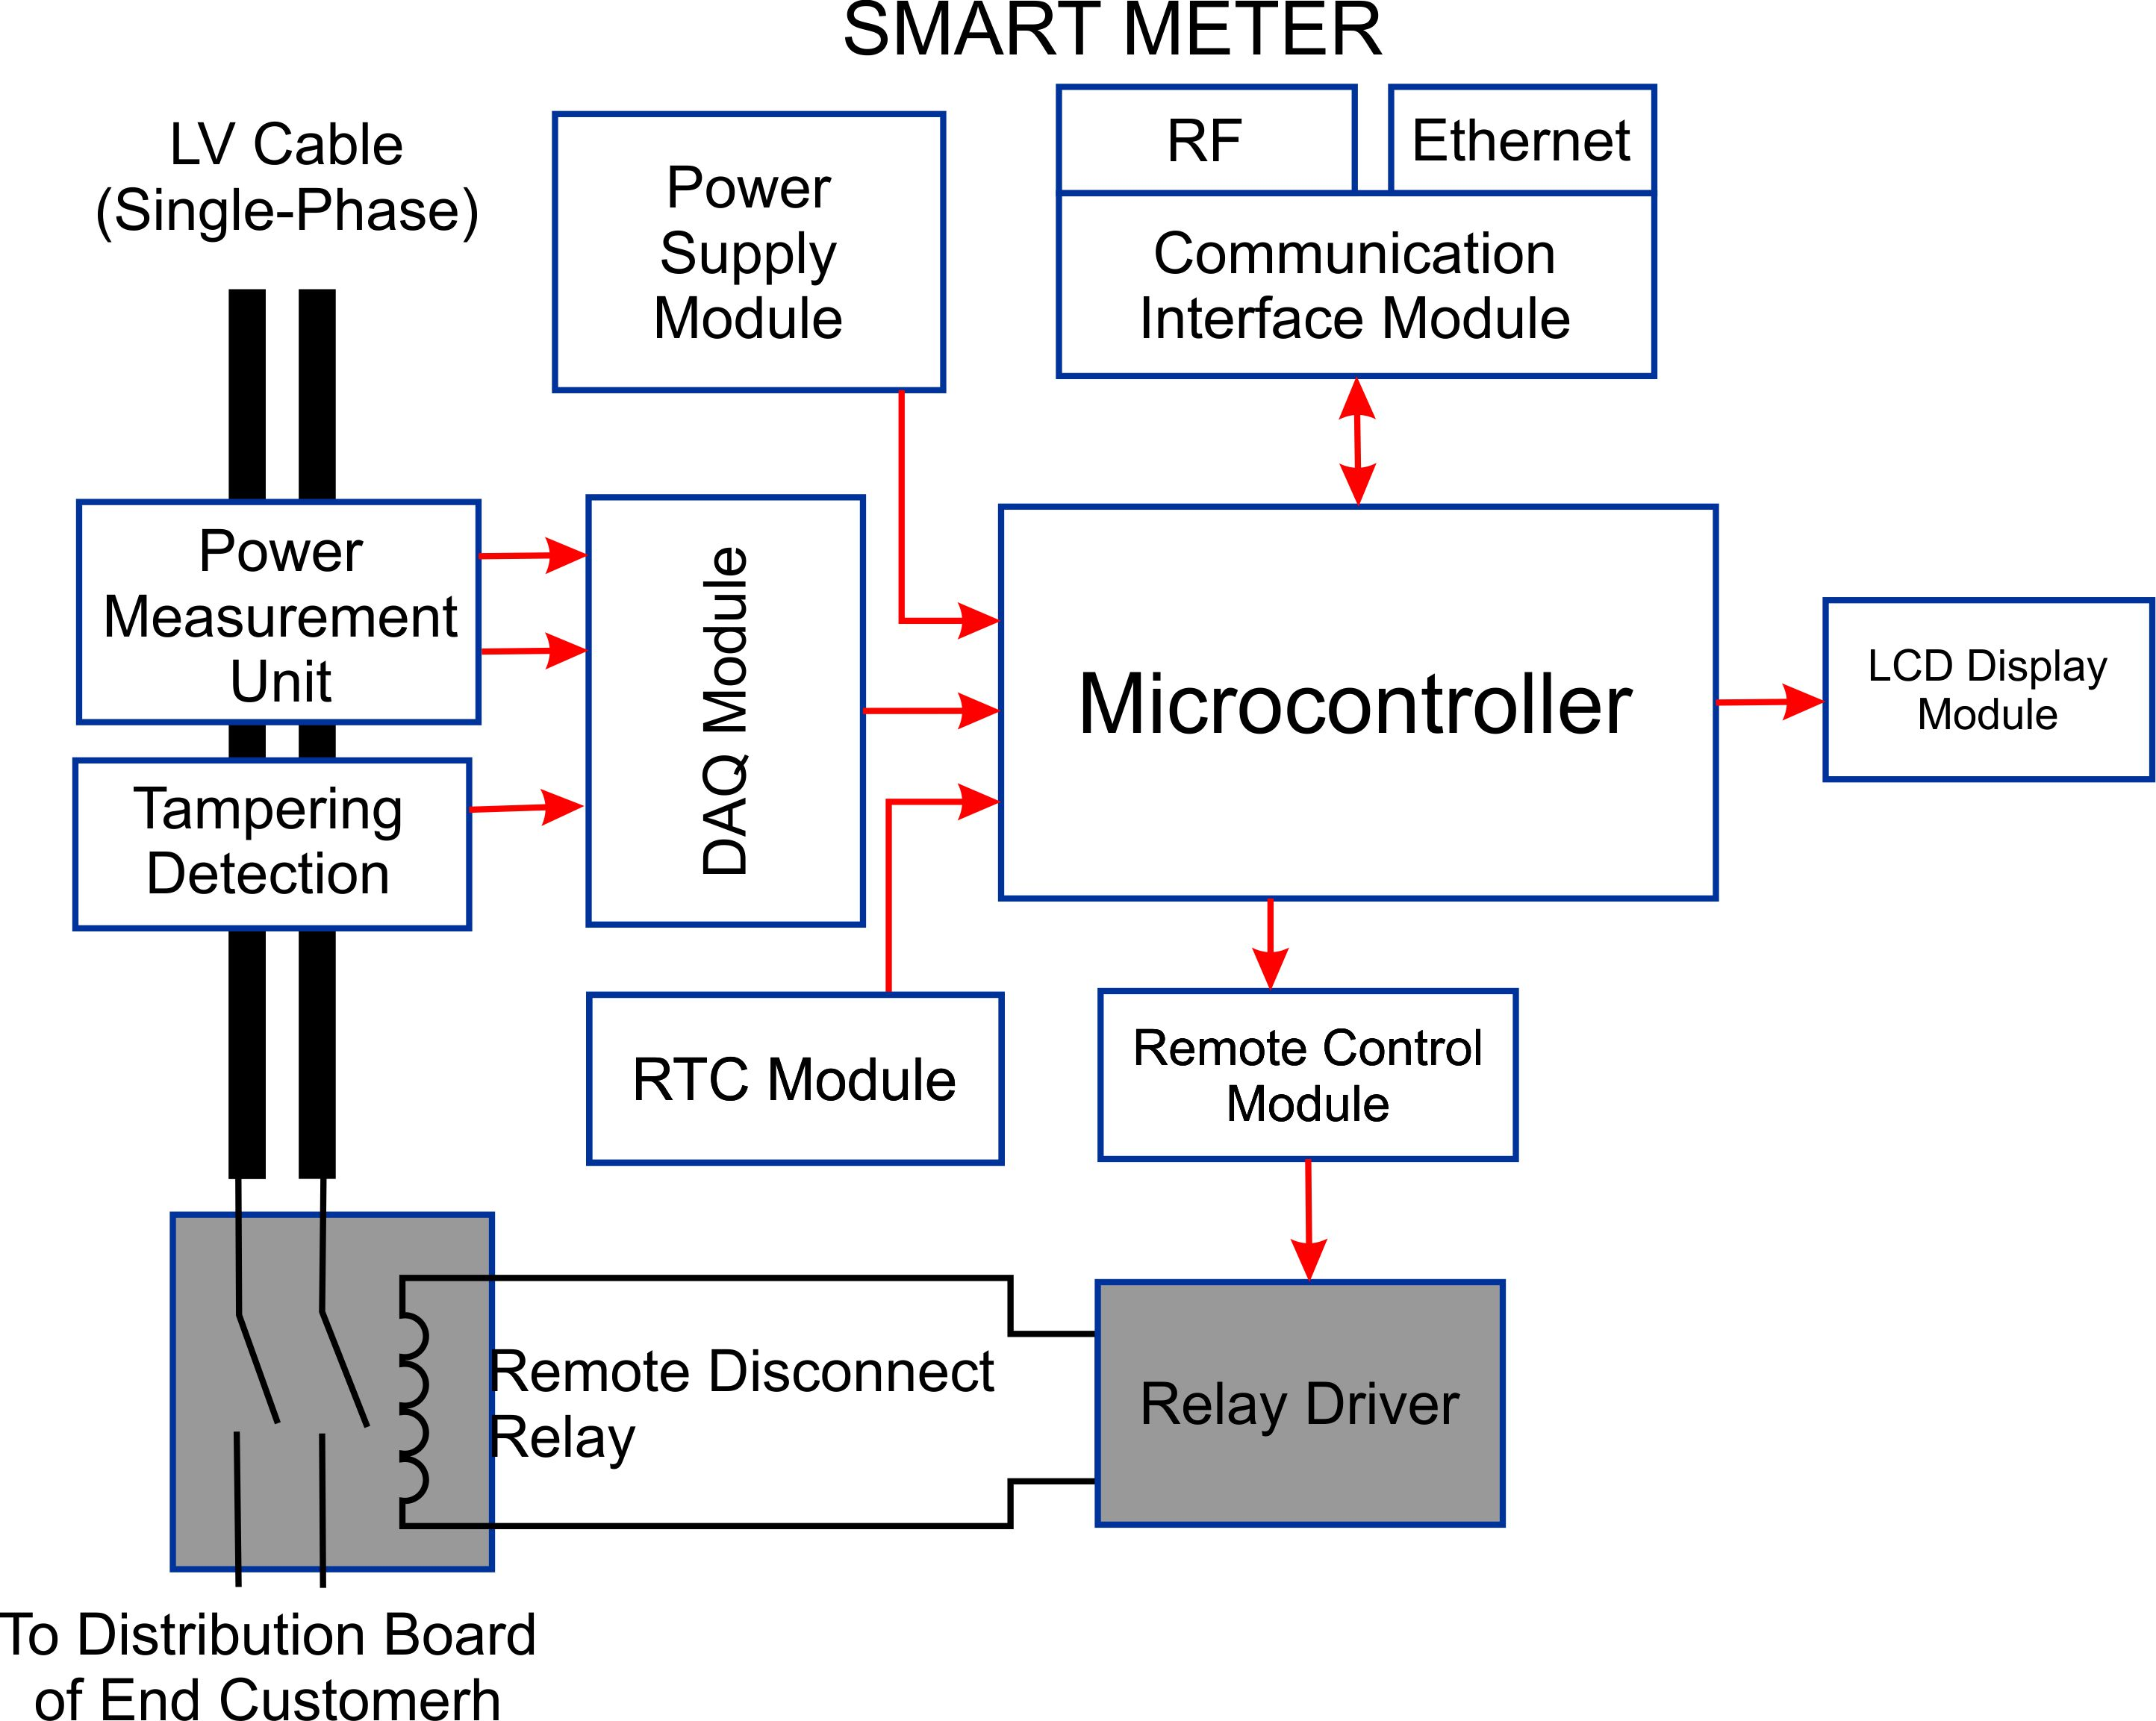

Components and Their Functions:

1. LV Cables (Single-phase): These cables carry the low-voltage electrical power from the distribution network to the smart meter. They are typically single-phase, meaning they carry power on one wire with a neutral conductor.
2. Power Supply Module: This module converts the incoming AC power from the LV cables into DC power, which is suitable for powering the electronic components within the smart meter.
3. Power Measurement Unit: This unit measures the amount of electrical energy consumed by the customer. It continuously monitors the voltage and current flowing through the meter and calculates the energy consumption.
4. Tampering Detection: This feature helps detect any attempts to interfere with the meter's readings or operation. It can monitor for physical disturbances, changes in the meter's internal components, or unusual power consumption patterns.
5. DAQ Module: This module collects data from various sensors and other components within the smart meter. It also stores event logs, which record important occurrences like power outages, tampering attempts, or meter malfunctions.
6. Microcontroller: The microcontroller is the "brain" of the smart meter. It processes the data collected by the various modules, performs calculations, and controls the overall operation of the meter.
7. RTC Module: The Real-Time Clock module keeps track of the current time and date. This information is used for time-stamping data and event logs, as well as for scheduling tasks like meter readings and communication with the utility company.
8. RF Communication Interface Module: This module enables wireless communication between the smart meter and other devices in the network, such as the utility company's data collection system.
9. Ethernet Communication Interface Module: This module provides wired communication capabilities, allowing the smart meter to connect to a local network or the internet for data transfer and remote control.
10. Remote Control Module: This module allows for remote control and configuration of the smart meter. The utility company to update firmware, change settings, or perform diagnostics remotely can use it.
11. Relay Driver: This module controls the operation of relays, which are electromechanical switches used to control the flow of electricity. In the context of a smart meter, relays can be used to disconnect power to the customer's premises in case of non-payment or other emergencies.
12. LCD Display Module: This module provides a visual interface for the user to view information such as current energy consumption, past usage history, and any error messages.

How it Works:

1. Power Input: The LV cables supply electrical power to the smart meter.
2. Power Conversion: The power supply module converts the AC power to DC power for internal use.
3. Energy Measurement: The power measurement unit continuously monitors voltage and current to calculate energy consumption.
4. Data Collection: The DAQ module collects data from various sensors and stores event logs.
5. Microcontroller Processing: The microcontroller processes the collected data, performs calculations, and controls the overall operation of the meter.
6. Communication: The RF and Ethernet modules enable wireless and wired communication with other devices and systems.
7. Remote Control: The remote control module allows for remote configuration and control of the meter.
8. Display: The LCD display shows relevant information to the user.
9. Relay Control: The relay driver controls the operation of relays, which can be used to disconnect power if needed.

